MSFS HudBar V 0.45.0.42

See (V0.45) indications for updates from the previous version (V0.43/.44)

# Display essential Information as Bar or Tile at any side of the primary screen Or use the Window to have it anywhere you like

* Displays more than 70 essential aircraft and flight information items as Bar, Tile or Window
* Supports 1 and 2 engine aircrafts (Prop/Engine RPM, N1, Fuel Flow for each)
* Provides 5 different content profiles which are fully configurable
* The pilot can directly activate Autopilot commands
* Auto Elevator Trim on a click
* Bottom/Top Bars work best with wide screen monitors
* AutoSave of the Flight (FLT file) at 5 Min intervals
* Flight Recorder, create KML + Json file as KMZ file
* 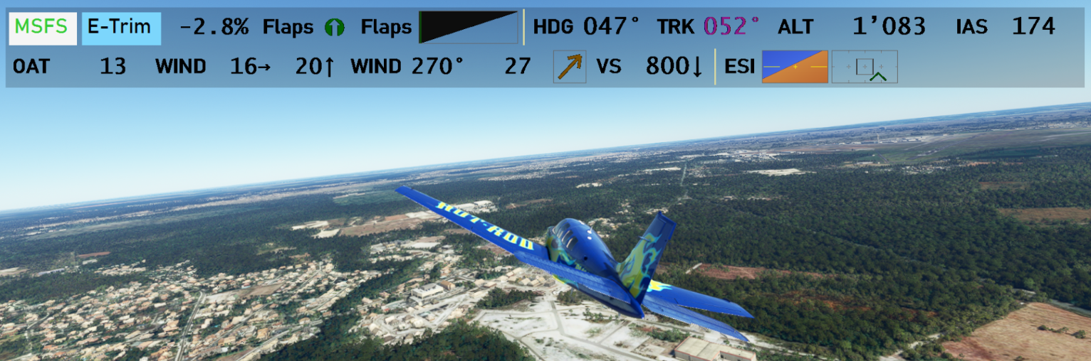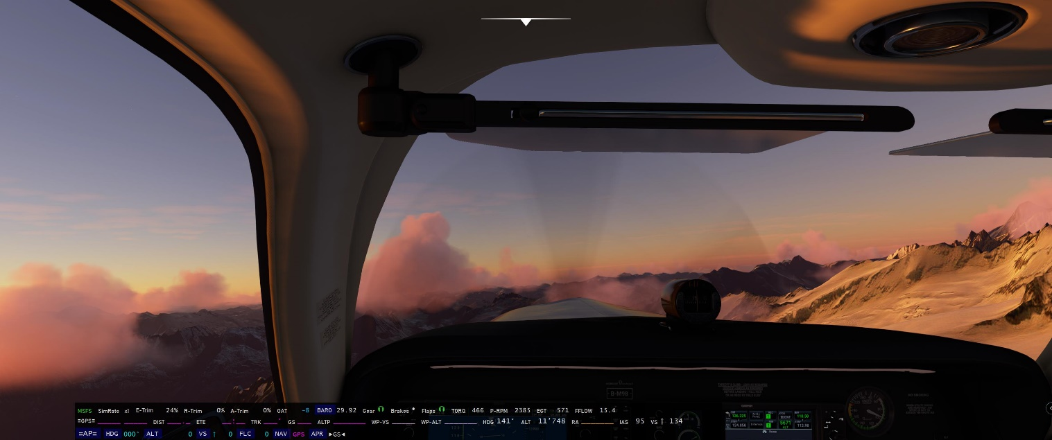FS20_HudBar scale 50%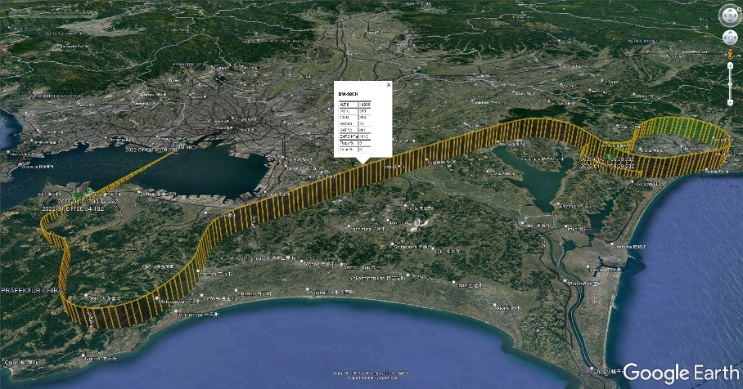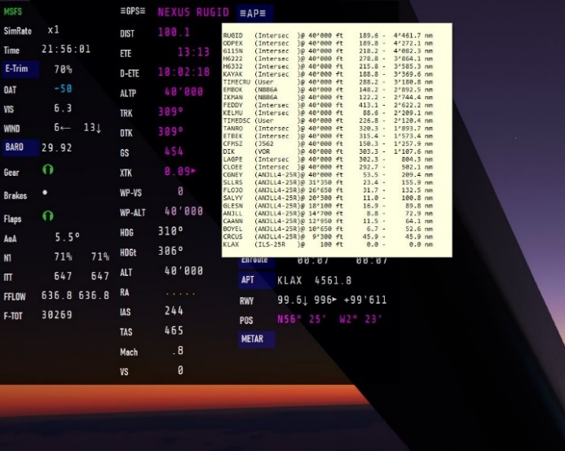Flight Bag ‚light‘ – display image documents with zoom and drag



# Usage

* Deploy the release all zip content in a folder (no installer provided or needed)

Best is to start MSFS first, then the Bar (but the Bar should connect the sim in any case - MSFS turns green)

* Start MSFS2020 first and once the Main Menu is shown
* Start FS20\_HudBar.exe
* It attempts to connect to the Flight simulator in 5 sec intervals, but shows MSFS in red while it cannot connect
* Note: the shown values are a bit meaningless until the aircraft and flight is live  
  Also note that the bar is shown on the **++PRIMARY monitor++** at the bottom of the screen

If you are using it the first time, there are some default profiles set.   
– just head straight to the Configuration and check the ones you like (right click the bar – Configure...)!

* **Right** Click the Bar and choose from the pop up menu
  + To **select** a Profile (1..5 - your names)
  + To **Configure**.. to check or uncheck the items to be shown
  + To **Exit** and stop the program
* The Hud can be shown as **Bar** or **Tile** or **Window** or **Borderless Window**  
  (to be changed in Configuration, default is Bar at the Bottom of the screen)
  + Bar: a full width window attached to the defined side of the screen
  + Tile: a window sized to accommodate the selected items  
    A Tile can be moved freely along the side where it is attached to
  + Window: like Tile but freely movable with a window bar
  + Window no border: like Tile but freely movable without window bar

# What is shown

Fields can be selected to be shown in the Configuration Window

The sequence can be adjusted to your needs in Configuration

From the Left - MSFS indicates if the Bar is connected to the Simulation (**red** if not connected)

Then there are: Trim, Gear, Brakes (Park), Flaps

Followed by: Engine Values, GPS data, Aircraft data and Auto Pilot Indications, Checkpoint meters

See below for some of the items available

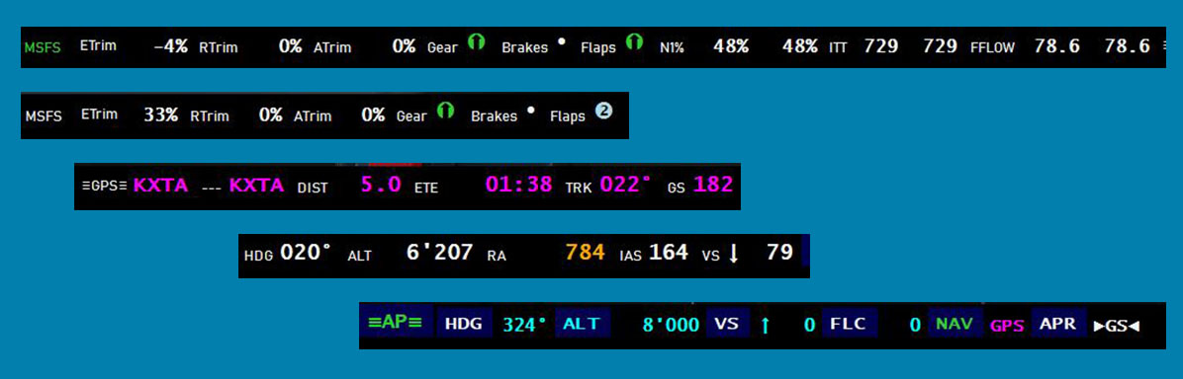

# Clickable Commands

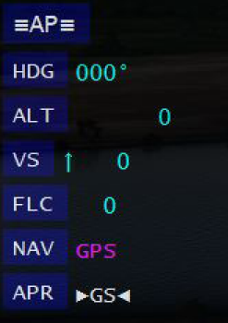In general when you see a label with a dark blue background and when hovering with the mouse pointer it turns to a hand cursor – the item is actionable.

## Autopilot commands

Actionable autopilot command are:

-AP-, HDG, ALT, VS, FLC, BC, NAV, APR and YD, LVL

Clicking them will toggle the state if this is supported by the Sim

## Setting the BARO to the current pressure

Click **BARO** to set it to current (same as the keyboard B button)

## Reset SimRate to 1x

Click **SimRate** to set it back to 1x

## E-,R-,A-Trim Reset

Click the label to set the trim value to 0% (reset Trim)

## Automatic Elevator Trim

**A-ETrim** – Aside from showing the current Elevator Trim % it provides an Auto Elevator Trim function:

Clicking the **A-ETrim** label will activate the Auto Elevator Trim module for about 20 seconds.  
It will display **A-ETrim** in green color while active - clicking the active module again will switch it off  
Note: the module controls the Elevator Trim in a way to level the aircraft towards zero vertical speed.  
It may or may not work to your expectation.. so use it only if you feel comfortable with.

## METAR

The **APT** and **METAR** action labels will retrieve the latest Metar information from an external server when clicked (see also chapter METAR Data Retrieval).  
Once the information is available the Background will turn to the FlightCondition color (green, blue, red, magenta, orange(below ILS) ) and hovering the mouse over the label will show the Metar message in plain text.  
🡪 Be aware that for some airports and locations there is no Metar available, then it tries to find the closest weather station within a range, if this does not succeed the Background color remains dark blue.

**APT** tries to retrieve the Metar from the Airport ICAO ID shown or the closest weather station.   
**METAR** gets the Metar from the nearest weather station found within max. 500 Statute miles in direction of flight (current bearing when clicked), the returned station is sometimes not really what one expects, but what the Metar server provides… (Cannot change it though).

**The Metar is real weather information at the location i.e. suitable when using Live Weather.**  
– Sim weather cannot be retrieved outside the sim.

## Moving a Tile Hud or Window without border

If a profile is set as **Tile** one is able to move the window along the bound edge of the screen

If a profile is set as **Window no border** one is able to move the window anywhere on any screen

Movement is available if the cursor shows up as Cross with Arrows

Click the **Left** mouse button and drag the window, it will remain attached to the bound border while moving it if it is a **Tile** else you can move it anywhere.

# Graphic Items (new V0.45)

Graphic items are available for most properties where there is a defined range i.e. Percent Values, the VARIO, Spoilers, Flaps. If the SimConnect interface does not provide a hint of a valid range, sorry there is no graph…

There are a number of different graphs:

## % Range Items

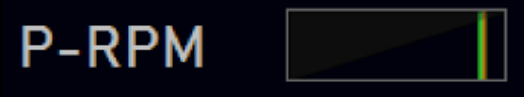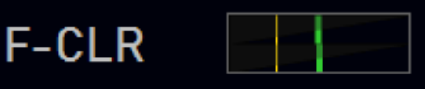e.g. Propeller RPM – the full range is 0..110% with a red bar at 100% - the value below is Prop RPM 1999 and 100% is given as 2000 from the Acft. Config file. If the value goes above 105% the background turns reddish.

If there are two items e.g. engines, tanks – it is always L (upper) and R (lower) the graph is split in two sections.  
Above right the tanks for L and R where the lower warning range (yellow bar) is set to 25% and the filling is about 50%. (BTW. sometimes the limits are off… - not updated or otherwise wrong, needs a fix by the Acft. Designer)

## Flaps and Spoilers/Speed Brake

0..100% and the bar indicates the position (here about 30%)

Or Flaps Position 1 = 50% of a Bonanza G36

## The ‚ESI Panel‘

Left part is an attitude display, the right part a flight path indicator where the full vertical scale is +-6° from center for both types. The horizontal scale of the flight path indicator is +-12°.

  Center square is +-3° in all directions. Marks indicate 6°.

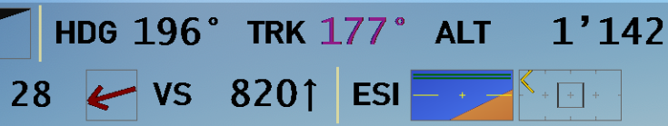For the flight path the vertical deviation is the flight path angle and the horizontal deviation is Track-Heading where the center is the heading of the Acft.   
If the range is exceeded the Attitude display shows two bars on top or bottom.   
The flight path will have a yellow arrow on the side it went off screen. It still tracks the one dimension which is in range – see above right for an example. The track is off by < -12° from heading but the FPA is about 4°.  
*This was an upwards turn with 28kt wind from the right side.*

## The VARIO

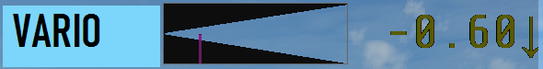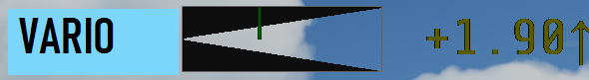The VARIO is folded in two parts. Left is 0, right upper is 5m/s max, lower is -5m/s max, the upper scale shows a green bar, the lower a magenta one. The number is a damped value (kind of an average but not quite..)

## Wind Arrow

Direction from where the wind hits the Acft nose.

The color of the arrow follows a Beaufort scale:  
White: <=1(1kt); Green: <=3(7kt); Yellow: <=5(16kt); Orange: <=7(28kt); Red: <=9(41kt); Magenta: >9

* **In general one needs a larger Font to use graphic items, else they may become unreadable.  
  Also great while in 3P to maintain some oversight.**

# Other information

## Flight Recorder:

If **enabled** in **Configuration** HudBar records the flight and provides a KML (Google Earth etc.) file and in addition a JSON data file.

The KML file is zipped as compatible **KMZ** file. The JSON file is included in this archive in the ‘files’ folder.

**Find it in <MyDocuments>\MSFS\_HudBarSave\** as YYYY-MM-DDThh\_mm\_ss.**kmz** file.  
KMZ files can be opened in Google Earth the same as KML files.

To enable go to **Configuration** and check **Use Flight Recorder**

To toggle recording on/off use and **click** the HudBar Item **Fl-Rec**:

Toggle ON (**recording**) will start and collect data at intervals until toggled OFF again.  
Intervals are derived from the flight dynamic (1 up to 8 sec intervals)

Each time it is toggled **OFF** (not recording) a KMZ file of the captured data is written.

The KML recording shown in Google Earth provides a graph of the recorded flight which can be animated using the GE Track Player.

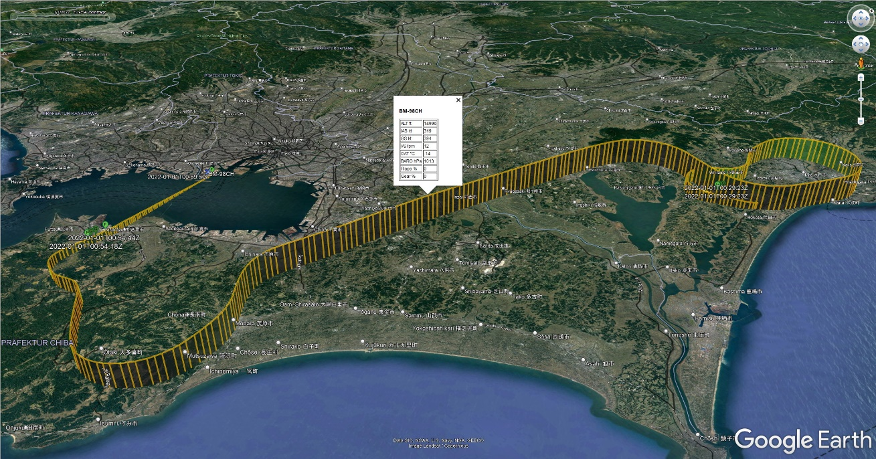

Each vertical line is a 5sec marker and can be clicked to show some inflight data at this point.  
Green place marks F, G indicating change of Flaps and Gear, R and T for Takeoff and Touchdown.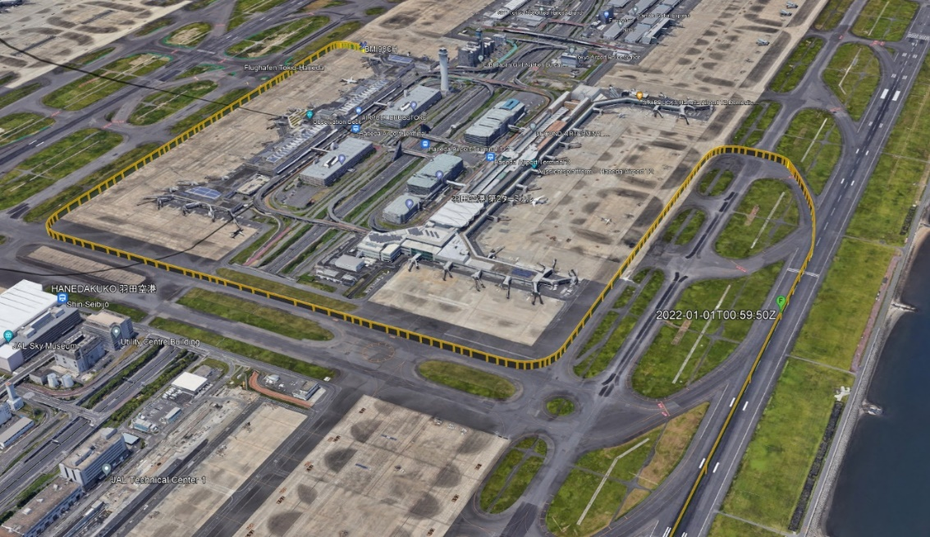

## Interactions:

1) We have seen small disruptions (stutter) when saving an FLT files in MSFS.   
To accommodate **AutoSave** is now a drop down allowing to choose from:  
 **AutoBackup Disabled**, **AutoBackup (5 Min)**, **AutoBackup + ATC**

Where:

* **AutoBackup Disabled** is no FLT saving from the App at all.
* **AutoBackup (5 Min)** will save and backup an FLT file only every 5 Minutes
* **AutoBackup + ATC** will save an FLT every 30 sec and therefore providing the most recent MSFS ATC assumed flight plan in the corresponding items (see below for notes on flight plans).

2) The **Auto Pilot** Settings for **HDG**, **ALT**, **VS** and **FLC** accept **mouse scroll** input (the cursor is a NS arrow).  
You may dial the setting Up and Down with the mouse wheel.  
*Note: as the Sim captures the mouse wheel for zoom (default) you may need to click in an empty space of the bar or otherwise out of the Sim window in order to not adjust AND zoom at the same time (cannot help here..)*

3) The App is able to handle hotkeys in order to **show/hide the Bar** and to **switch Profiles** (see **Hotkeys** below)

## Checkpoint Lapse Meter:

* Click one of the CP1..CP3 labels to start the meter, it shows the time elapsed and the distance from the trigger location (Lat/Lon Distance). The label turns green when clicked once.
* Click again to re-start the meter
* Double Click to Stop

## Waypoint Estimates:

**WP-VS** – Which VS is required to arrive at the next Waypoint at the set altitude given the current GS assuming a straight flight. This requires to have a next Waypoint and its altitude other than zero, the altitude target is ALTP. The target altitude may change to a blue indication and using the AP set altitude when there is no GPS target altitude (=0).

**WP-ALT** – At which altitude is the aircraft when reaching the next Waypoint given the current GS and VS.  
This requires to have a next Waypoint.

## Flight AutoBackup (was AUTO SAVE)

Sometimes the Sim may let you down and exit for some reasons…

If in **Configuration** you do NOT Disable **AutoBackup** the program will capture Flight files (.FLT) at regular intervals to retrieve flight plan information.   
Having such files available allows the HudBar to copy them into a convenient location to maintain a flight backup in case needed. Saved FLT files are modified in order to allow you to go with the full MSFS menu.

The program saves such files every 5 Minutes and maintains a maximum of 12 files (last hour).  
*AutoSave files are not flight dependent – if you want to store them for later, copy them away into a new location, else they will eventually vanish while doing the housekeeping.*

The AutoSave location is the Users MyDocuments\MSFS\_HudBarSave folder

Files are named: AutoSave\_YYYY-MM-DDThh\_mm\_ss.FLT (e.g. AutoSave\_2021-08-22T16\_19\_35.FLT)

Note: During Missions the Sim is usually maintaining AutoSaves on its own and the HudBar will not save additional ones.

## Audible RA

There is a second RA (radio altitude) readout with the item name **RAv** which announces altitudes of 400, 300, 200, 100, 50, 40, 30, 20, 10 ft while descending.

It tracks the way down and will not repeat annunciations made before **unless going above** 410 ft before the next descend!

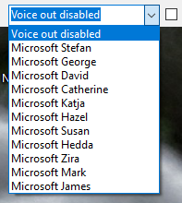Select your preferred voice in the Configuration.

* To test a voice just click into the voice name of the drop down box after selecting one.
* Change then Volume in the Windows Mixer for FS20\_HudBar

You may add voices in Windows Settings – Time & Language – Speech

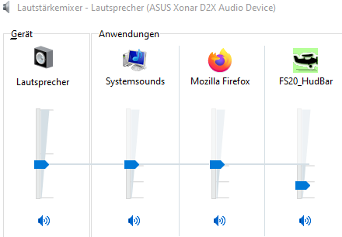There you may add e.g. English if you prefer English readouts.  
You may add even some of the English variants to choose a preferred one.

I.e. “James” has a rather formidable pronunciation (it is from the en-AU selection)

See also: <https://www.tenforums.com/tutorials/132456-add-remove-speech-voices-windows-10-a.html>

## Hotkeys

The App allows for two different types of capturing Input in order to Show/Hide the Bar and also to change between the profiles (1..5 -> left to right one in the Configuration).

The App allows to choose none, either or both of them but usually one or the other would be more practical. Default is both OFF.

Hotkeys are available for Show/Hide the bar, changing Profile 1..5 (left to right order in Configuration)

**Keyboard Hotkeys**: The App monitors the keyboard entry at a rather low level and acts when it sees the defined key presses. In general you want to define a hotkey as a combination of a modifier and a key. E.g. RCtrl+F10 or so.

🡪 This is independent from the Window that has the focus at the moment the keys are pressed.

🡪 Some key combinations are not possible (e.g. Return/Enter keys, Shift+Numpad keys)

**MSFS Hotkeys**: The App registers to some events in MSFS and will act on them when MSFS gets inputs:

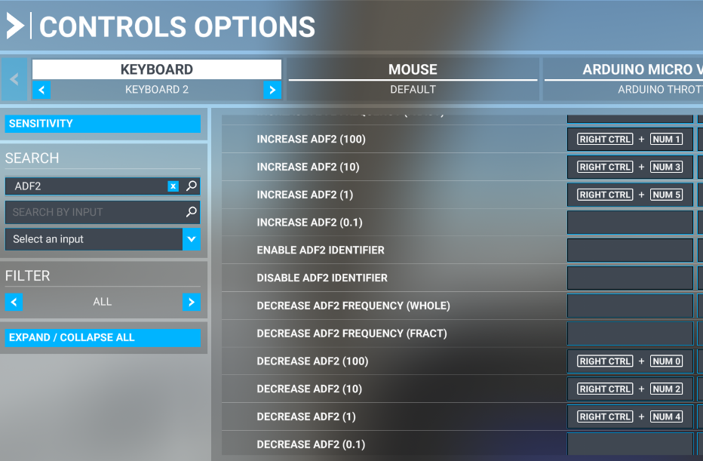 The App acts on some very sparsely used ADF2 Dial events as shown below:

You may configure keyboard and other devices to trigger these events as usual in MSFS. The Events are:

* Show Hide: ADF2\_100\_DEC
* Profile 1: ADF2\_100\_INC
* Profile 2: ADF2\_10\_DEC
* Profile 3: ADF2\_10\_INC
* Profile 4: ADF2\_1\_DEC
* Profile 5: ADF2\_1\_INC
* Flight Bag: ADF2\_FRACT\_INC\_CARRY

In the example they are mapped to Right Control + Numpad\_0..5 but you may map them anywhere.

🡪 To use only the keyboard input and to act whether or not MSFS has the input focus – use Keyboard Hotkeys,   
if you want to map you own keys and/or input devices – use MSFS Hotkeys.

## Transparency and Appearance

**Transparency** can be set per profile from **Opaque, 10% .. 90%**.

* When selecting a more transparent background (50%..90%) one will observe rather jagged edges on brighter backgrounds such as a sunny sky. I am afraid but this is NOT a bug to be corrected in the program but how Windows renders such things.

The **Appearance** of the values can be change in either the context menu (**Right Click** – **Appearance** - selection) or easier by **clicking the MSFS status label** with the mouse whereby switching through all 3 modes.

**Appearance** is related to the items shown and can be chosen from **Bright**, **Dimmed** and **Dark**.

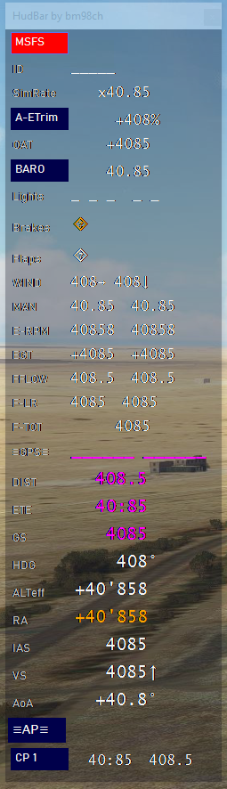 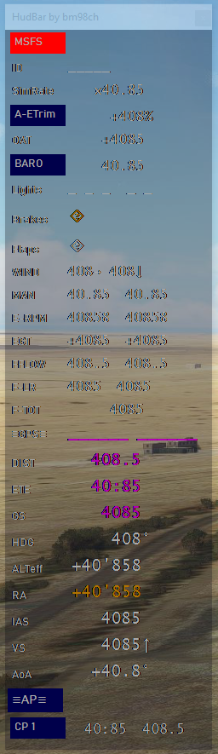 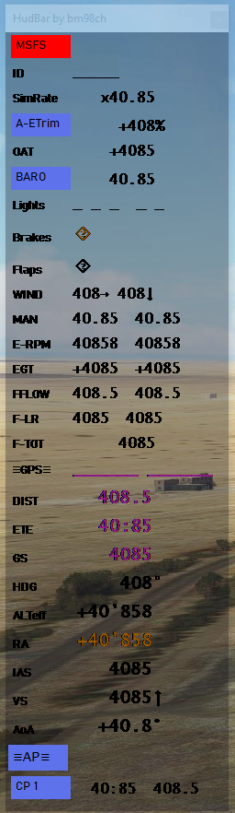

Above an example of 70% Transparency on a brighter background (Bright, Dimmed, Dark)

Darker backgrounds are not so much of a problem rather than that **Bright** values may be distracting, so use the **Dimmed** appearance for a more comfortable experience.

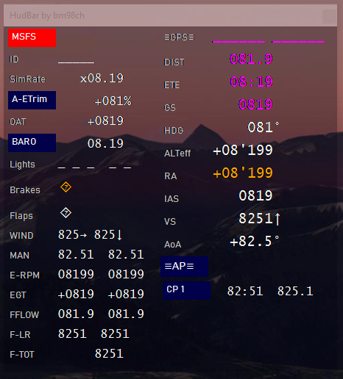 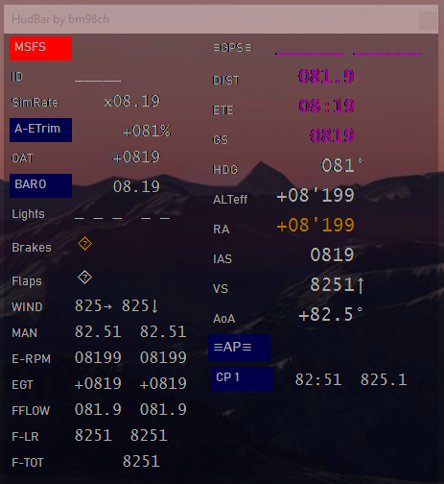

## Instances

You may want to start the HudBar more than once and get independent display bars and therefore programs running.

However they share the same Settings i.e. the location is saved from the last movement on any of the instances.  
In order to have truly independent instances with their own settings (all settings in Config and locations etc.) an Instance Name can be added to the Command Line when starting the HudBar.

No command line parameter is considered and referred to as ‘Default’

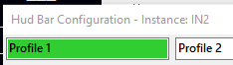

If you provide an Instance name to start the HudBar it will be shown in the Window Title (Window Bar and Configuration)

Here “IN2” was used as Instance name



You may start instances the easy way by creating a **Desktop Shortcut** and then modify the **Properties** of the **Shortcut** (right click) by adding an Instance name to the **Target** field:   
This is the command line; add a space and the name at the end of the text field – here IN2 was added

Then may be rename the **Shortcut** in order to recognize it later.

**Note**: you may want to enable the voices only in once instance as they will all talk when enabled…

## Voice Callouts

Each one can be checked (enabled) or unchecked (disabled)

**Parking Brake** announces “Parkingbrake Set” and “Parkingbrake Released”

**Gear state** announces “Gear Up” and “Gear Down” when Safe Gear is reached

**Flaps state** announces “Flaps Up”, “Flaps Down”, “Flaps NN” where NN is the % deployment number i.e. 10, 20, … the number depends on the aircraft flaps stages available  
– when the Flaps handle is moved (not when the state is reached)

**GPS Waypoint sec.** announces the GPS ETE to the next Waypoint when crossing 90, 60, 30 seconds as “Waypoint in NN” where NN is 90, 60, 30

**AP GS Capture** announces “Glideslope” or “Glidepath” when the GS is captured i.e. turns green (but not when it is lost afterwards)

**AP ALT Hold** announces when the AP changes to ALT holding (ALT turns green) with the altitude set as “Holding NNNN feet” or “Holding Flightlevel NN” when at or above 8000ft – this is usually before the alt is reached.

**OAT Icing** announces "Low Air Temperature" when the OA temp gets down to around 3°C and "Icing Alert" at around 0°C.

**Fuel Warning** announces “Low Fuel Alert” when the fuel @ current flow will last less than ½ hour.

**IAS Rotate** announces “Rotate” when on ground and at or above Sim provided rotate speed

**Spoiler** announces “Spoiler ..” similar to Flaps – Spoiler and Speed brakes are the same in the Sim

Note: the RA callout remains an Item to be checked per profile

## Flight Bag

A ‘light’ version of a Flight Bag was added.

* An independent Pop-up Window (stays top most) will show up if requested.
* The Window allows to choose from image files contained in a folder.
* An image can be zoomed in or out and dragged within the window.
* Supported image file formats are PNG and JPG

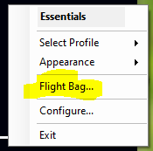Tip: scale the image in a way that the resolution is high enough to read it properly at the most used zoom level, usually this is around 1400 pix on the longer side – but you may try and find what works best.

The Flight Bag can be **shown/hidden** with the Context Menu ‘**Flight Bag…**’

**Show/Hide** can be assigned to a **keyboard shortcut**. It is also mapped to a MSFS command (ADF2\_FRACT\_INC\_CARRY), both must be enabled in Configuration (see Hotkeys above).

### Configuration:

In order to use the Flight Bag you must select the folder where your images are located – go to Configuration –



Default is the directory **DemoBag** in the App folder – supplied with some demo images in the App distribution.

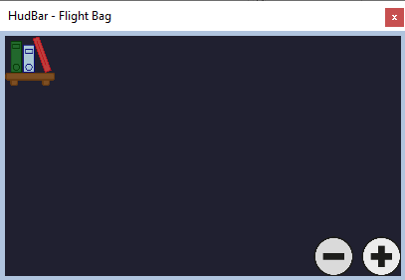Click ‘**Flight Bag Folder…**‘ and choose any directory to use.

Usage:

The first time the window will open empty   
– Click the **Book Shelf Icon** in the top left corner to load the documents (images)

From the list of documents **click** the one to display.

**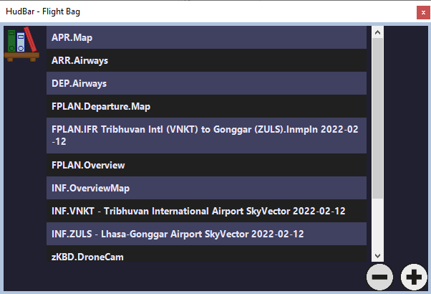Zoom** the document with the mouse **scroll wheel** or **click the +- icons** in the bottom right corner.

Use the **left mouse click and drag** to move the document in the window.

**Click right** to reset the zoom and re-center the document.

Click the Book Shelf icon to select another document.

**Resize** the window as usual in Windows.

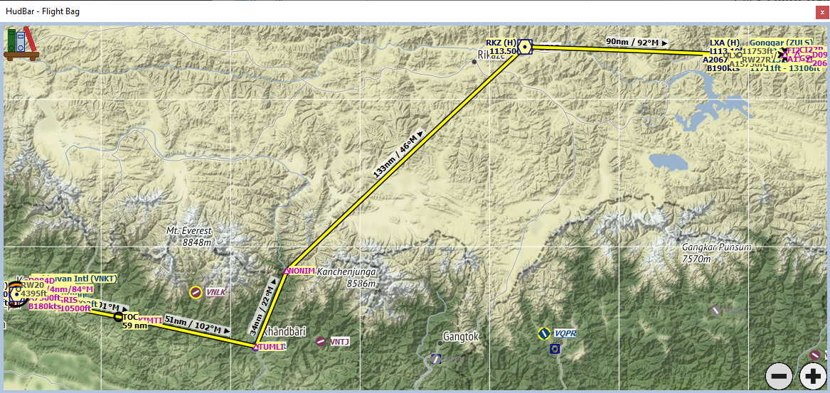**Hide** the window with Hotkey, Context Menu or the X icon.

Example from the Demo included

# Configuration

The currently selected one will show up with a green background color (here it was “Airbus..”)

**Name** and use up to 5 different profiles per instance (see Instances above)

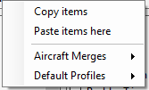The Window Title refers to the Instance (Default or the Instance Name used)

Type the profile name into the field of the topmost row (here Prop, TMB…)

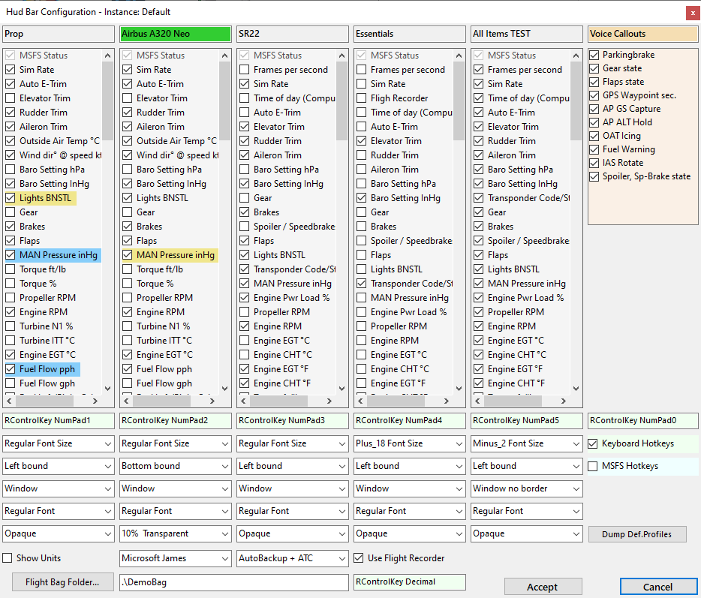

**Right Click in the profile name** opens a context menu.

**Copy Items** from a Profile then

**Paste items here** -> in another Profile.

**Aircraft Merges** -> load engine readouts and fuel settings derived from the instrument panel of this particular aircraft.

**Default Profiles** –> 5 defaults to load.

*In general when loading defaults you may review the items to e.g. select another Unit, or add some special items, delete unwanted ones*

*Also review and adjust the line brakes (green marks)*

General Settings are:

* Check **Show Units** to display the units along the values
* Select the audible **Voice** from the ones available – **Voice out disabled** for silence (see Chapter above)
* Check **AutoBackup …** to have the Bar retrieving and saving FLT files for flight plan handling
* Check **Use Flight Recorder** to use it.. (see chapter Flight Recorder)
* **Keyboard Hotkeys** / **MSFS Hotkeys** (See also chapter ShortCuts above)
* **Flight Bag** (see also chapter Flight Bag)

For any profile:

* Check / Uncheck the items in the list which to show / hide items
* If Keyboard Hotkeys is checked.. **Double click the green Hotkey field** and enter a combination
* Select a **Fontsize** from Regular, Plus-2, -4, -6, -8, -10, Minus-2, -4, Plus-12, -14  
  (the bar rescales to multiple rows/columns to fit all checked items on the screen)
* Select the **Alignment** of the bar for any profile (left, right, top, bottom)
* Select the **Kind** of the bar – where Bar is a full width or height band and Tile is a rectangle bound to the alignment border, the size of the tile will adapt to the items shown  
  Window is similar to Tile however it can be moved freely to any position and screen  
  Window no border same as Window above but looks like a Tile
* Select from **Regular** or **Condensed** Font type
* Select from **Transparency** for Opaque to 90% in 10% steps
* Checked items are shown in either horizontal or vertical order as they are shown in the configuration panel.  
  See below how to re-arrange the order here and to apply new lines

## Keyboard Hotkey Setup (light green settings)

If you want to use Keyboard Hotkeys – first check the box **Keyboard Hotkeys**; the row of green items will appear.

**Double click** the green field for which you want to define a Hotkey.  
*Hotkeys in Profile columns allow to switch to this Profile using the hotkey.   
The rightmost one (above the Checkbox item) defines the hotkey to Show/Hide the HudBar.*

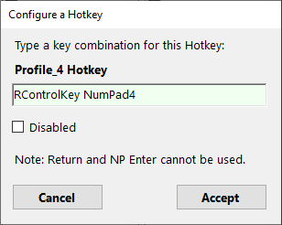If a field is empty it means that there is no hotkey defined for i.e. Disabled.

Double clicking a green field will pop up the setup window:

Click into the green field and type the desired hotkey.  
Usually one would use a combination of Ctrl, Shift, Alt (Menu) and a Key.  
The App can distinguish between the left and right modifiers.

**Accept** or **Cancel** to close the window.

Check **Disabled** to clear and not use it. Uncheck to be able to enter a hotkey.

*Some Key names may sound a bit strange (Win names) such as OemPeriod (.) etc.*

*Note: Some combinations are not possible (Win limits) e.g. Return and Numpad Enter, Shift + Numpad items. …*

## Move an item within a bar:

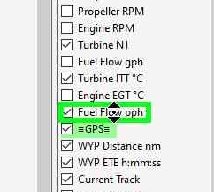*Works about the same as Drag and Drop*

* **Left** Click and hold the item which will be moved
* Move the mouse up or down – the cursor will change to a NS sign
* Drop (**Release** the mouse button) – the item should appear at the drop position  
  *Note: Due to the rearrangement of the affected items the behavior is different if you move an item up or down – sometimes you need a second drag to place it where you want it to be*
* 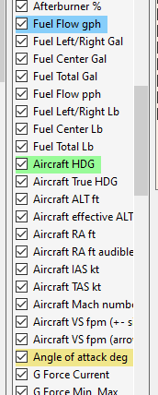Hit **Escape** or move the mouse out of the drop zone and release the mouse button if you wish to cancel the movement

## Start a new line for the item and its successors:

* **Right** click an item to start it on a new line/column in the Hud
* New Lines are indicated with items that have a light green background color (e.g -GPS- above and Aircraft HDG)
* **Right** click again until the background color reverts to light gray to remove the New Line

## Insert a Separator before an item:

* **Right** click an item until the background is either blue or yellow to insert a separator in the Hud (Blue is a darker blueish and yellow a brighter yellow one)
* **Right** click again until the background color reverts to light gray to remove the Separator

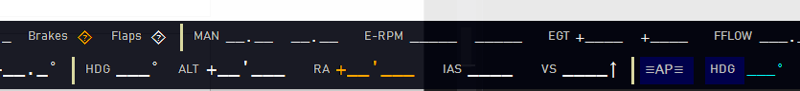e.g. below a brighter yellow separator on a horizontal bar on MAN, HDG and –AP–

*Note:  
Breaks are also considered when an item is not checked, NewLine takes precedence over Separators*

## Leaving the Configuration Window

* Click **Accept** to accept all changes made to the configuration
* Click **Cancel** to discard all changes made
* The window will close and the Hud is rebuilt according to the profile

All settings are automatically saved and should be available for any further use

# Available Info Fields

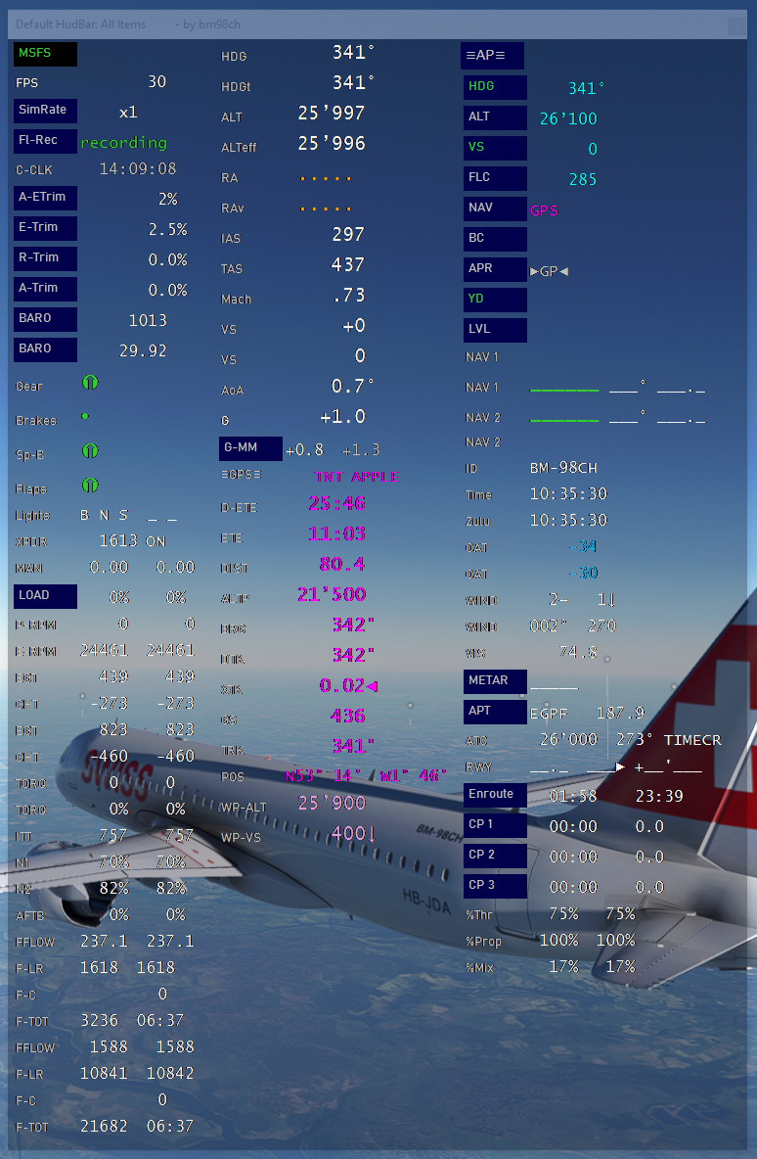

All Items (there are even more now…)

## Item Description

For Engine related fields the Bar shows up to 2 Engines.  
Once a 2 Engine aircraft is detected the left one is Engine 1 and the second/right one Engine 2

**SimRate x**: the current Sim Rate factor – if not x1 it is shown with yellow background, Click to reset to 1x

**FPS**: the frames per second as reported from the Sim

**Fl-Rec**: Flight Recorder status information – click to toggle recording on/off

**ID**: the aircraft ID

**C-CLK**: the current computers local time [h:mm:ss]

**Time**: the current Sim Time [h:mm:ss]

**Zulu**: the current UTC Sim Time [h:mm:ss]

**XPDR**: Transponder Code and State

**E-**, **R-**, **A-Trim**: Elevator, Rudder, Aileron Trim % values +- deflection; click the label to Zero Trim, scroll to adjust

**A-ETrim**: Elevator Trim % value with clickable Auto Elevator Trim

**OAT**: Outside Air Temperature [°C] or [°F]

**VIS**: Visibility [nm] (not reliable for the current MSFS I think)

**BARO**: Setting is available as [inHg] or [HPA] – chose one that fits the needs

**WIND**: Setting is available as Dir[deg] @ Speed [kt] +Arrow (new V0.45) or Cross- / Head-Tail Wind [kt]

**AoA**: Angle of attack degrees [deg]

**Gear**: either Up, down or Unknown (Transient) 

**Brakes**: Parking Brake indication - Set: Released:•

**Flaps**: either full up, down or steps in-between (depends on the number of steps available) ❶❷❸..   
or % Graph (new V0.45)

**Sp-B**: Spoiler or Speedbrake either full up, down or steps in-between ❶❷❸.. or % Graph (new V0.45)

**TORQ**: Engine torque value is available as [ft/lb] or [%] or % Graph (new V0.45)

**P-RPM**: Propeller RPM Value or % Graph (new V0.45)

**E-RPM**: Engine RPM Value or % Graph (new V0.45)

**N1**: Turbine N1 % Value or % Graph (new V0.45)

**N2**: Turbine N2 % Value or % Graph (new V0.45)

**AFTB**: Afterburner % Value or % Graph (new V0.45)

**ITT**: Turbine ITT Temperature [°C]

**EGT**: Engine Exhaust Gas Temperature [°C] or [°F]

**CHT**: Cylinder Head Temperature [°C] or [°F]

**MAN**: Manifold Pressure [inHg]

**LOAD:** The engine load percentage [%], Click to calibrate when the button color is yellowish  
 *Calibration may be needed for aircrafts the program finds no default values or if you find it wrong.   
 (MaxHP is not available in the Sim Interface)  
 -> Set the throttle to indicate* ***50% Load*** *in the Sim Cockpit instrument – then Click LOAD to calibrate.*

**COWL:** Cowl Flaps % Open Graph (new V0.45)

**FFLOW**: Fuel Flow value is available as pounds per hour or gallons per hour – chose one that fits the needs

**F-LR**: Fuel quantity Left / Right [gal] or [lb] get Amber readings when unbalanced more than 15% of Total Capacity

**F-C**: Fuel quantity Center [gal] or [lb] or % Graph for C and LR (new V0.45)

**F-TOT**: Fuel quantity Total [gal] or [lb] + Fuel Time remaining (at current consumption)

**-GPS-** Shows the previous and next Waypoint if a flight plan is active

***ToolTips*** *- hovering* the **-GPS-** label pulls the remaining ATC flight plan, hovering the **two waypoints** shows waypoint details from the flight plan (based on FLT file information - updated every 30 sec).

**DIST** shows the GPS Distance to the next Waypoint [nm]

**ETE** shows the GPS Estimated Time Enroute to the next Waypoint [h:mm:ss]

**D-ETE** shows the GPS Estimated Time Enroute to the next Destination [h:mm:ss]

**BRG** shows the GPS magnetic bearing to the next Waypoint [degm]

**TRK** shows the GPS magnetic ground track [degm]

**DTK** shows the GPS desired track to the next Waypoint [degm]

**XTK** shows the GPS cross track distance [nm]

**GS** shows the GPS ground speed [kt]

**ALTP** shows the GPS Waypoint Altitude if it is available [ft]

**POS** shows the Latitude and Longitude position of the aircraft

**Enroute** shows the elapsed times towards the WYP and TOTAL (Active, Click to restart tracking)

***Calculated*** fields when a "Next Waypoint" is available:

* **WP-VS** Estimated VS to WYP@ALT:  
  Calculated VS to reach the next waypoint at the proposed altitude with the current GS and DIST   
  (ALTP altitude when purple or Setting Alt when blue)
* **WP-ALT** Estimated ALT@WYP:  
  Calculated altitude at next waypoint using the actual GS, VS and DIST

*Note: the calculated fields are experimental they are rounded to the nearest 100.*

**HDG**: Current Magnetic Heading [degm]

**HDGt**: Current True Heading [deg]

**ALTeff**: Current effective Altitude [ft] (sim model based)

**ALT**: Current Instrument Altitude [ft] (baro corrected)

**RA**: Radio Altitude [ft AOG] available when <=1500ft AOG

**RAv**: Radio Altitude with audible readouts <=400 [ft AOG] available when <=1500ft AOG

**IAS**: Indicated Airspeed [kt];

***ToolTips*** *- hovering* the **IAS** label - if available, a tooltip shows the Reference Speeds provided by MSFS  
**IAS** turns Amber when closer than 5kts from config. Stall Speed and Red when at or below. (new V0.45)

**TAS**: True Airspeed [kt]

**Mach**: Mach number [M]

**VS**: Vertical rate [feet per minute] with Arrows or with +-Sign; step size is 20fpm

**VARIO**: TE Variometer+Avg [m/s] or [kts]; Click the ping modes: Green: only +, Blue: +-; DarkBlue: off  
or Graph+AVG (new V0.45)

**G**: G-Force current value [g]

**G-MM**: G-Force Min – Max [g], click to reset

**-AP-**: Autopilot Master (all Autopilot signs turn to **Green** text if active)

**HDG**: Heading Mode Sign and Heading Setting, click to toggle, scroll to adjust

**ALT**: Altitude Mode Sign and Altitude Setting [ft], click to toggle, scroll to adjust

**VS**: Vertical Rate Sign and VS Setting [fpm], click to toggle, scroll to adjust

**FLC**: Flight Level Change Sign and IAS Setting [kt], click to toggle, scroll to adjust

The 4 settings above can be adjusted with the mouse wheel up/down   
*Note: as the Sim captures the mouse wheel for zoom (default) you may need to click in an empty space of the bar or otherwise out of the Sim window in order to not adjust AND zoom at the same time (cannot help here..)*

**BC**: Back Course Sign, click to toggle

**NAV**: Nav Mode Sign and GPS Source – GPS active source shows GPS in purple letters else it is NAV1 or NAV2 in green letters, click to toggle

**APR**: Approach Mode Sign and Glide Slope/Path (**>GS<**) Capture, click to toggle. **GS** turns **green** if captured

**YD**: Yaw Damper Sign, click to toggle (validity depends on Acft type)

**LVL**: Wing Leveler Sign, click to toggle (validity depends on Acft type)

**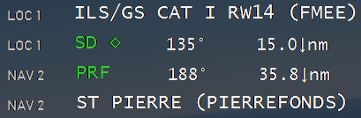 NAV1/2**: ID; BRG, DST [nm] – ID of the NAV/LOC where a double cross (‡) marks a LOC with glideslope, and Diamond (◊) once the glideslope signal from the LOC was detected.   
If the station is not identified the active Frequ. is shown

*Note: The distance arrow shows whether the current track is going towards or away from the station*

**NAV1/2**: Name – Name of the station for LOC mostly ILS/LDA + RWY (if provided by the Sim)

**RWY** shows the distance [nm], left/right deviation [ft] and height [ft] from the ATC assigned runway

**APT** shows the ATC assumed flight plan destination ICAO code and remaining distance in nm and ALT msl (new V0.43)

**ATC** shows the ATC assigned/expected Altitude ft and Heading deg and Next Waypoint ID

***ToolTips*** *- hovering* the **ATC** label pulls the full complete ATC flight plan

**METAR** when clicked retrieves the closest Metar in bearing direction, shows the station, distance and bearing when the response was retrieved.

***ToolTips*** *- hovering* the **APT** or **METAR** label shows the latest Metar message (Click the label to retrieve the information from the external server).

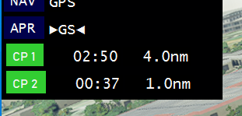**CP1..3**: Checkpoints to track elapsed time and Lat/Lon distance from start point  
click a CPn label to start tracking, it turns green while tracking, click again to set a new start point

**%Thr**: The Throttle handle setting [%]

**%Mix**: The Mixture handle setting [%]

**%Prop**: The Propeller handle setting [%]

*Note: Those values lag with e.g. Joystick movements when making fast adjustments – it’s the Sim not prog…*

## Note on Flightplans:

The flight plan in MSFS is a strange beast… and not always what one would expect.

*If you experience problems try to* ***uncheck*** *the FLT AutoSave and restart and see if it works OK.*

**Flight Plan detection and collection is Enabled in Configuration by selecting AutoBackup + ATC**

The aim of the program is to show what the ATC assumes your flight plan is by capturing the FLT file output once every 30 sec to not overloading the sim.

The file location is %TEMP%\HudBar\ and file MostCurrent.FLT

A flight plan usually changes after IFR clearance, once you are on arrival or approach i.e. waypoints are added and removed on the fly during such procedures. It may need ATC-Clearance and your read back to get new legs added or changed. **ATC assumed flight plans may not match your GPS flight plan though…**   
Also the flight plans altitudes for waypoints are usually not what you would been asked to maintain by ATC and may even violate min/max altitude restrictions. They are added to the report to have it complete and may be once it will match. Lately there were quite some changes to how MSFS maintains flight plans – so the current program may have it wrong- let me know, then we may improve it over time. Pls provide the FLT file.

You may find such a flight plan:

Flightplan: RJAH-RJAA

ATC Altitude : 7’000 ft

ATC Clearance: Own Navigation

Waypoints:

RJAH (Airport ) 0.0 - 0.0 nm @ 107 ft

D0 (HOKT5E-03R) 1.6 - 143.8 nm @ 450 ft

D1 (HOKT5E-03R) 20.7 - 142.2 nm @ 750 ft

D091W (HOKT5E-03R) 4.0 - 121.5 nm @ 4’900 ft ̅ 8’000

HUC27 (HOKT5E-03R) 0.0 - 117.5 nm @ 5’700 ft

D4 (HOKT5E-03R) 3.5 - 117.4 nm @ 5’700 ft ̲ 11’000

D5 (HOKT5E-03R) 3.5 - 113.9 nm @ 6’400 ft ̲ 11’000

D6 (HOKT5E-03R) 2.4 - 110.4 nm @ 7’100 ft ̲ 11’000

HOKTA (HOKT5E-03R) 11.3 - 107.9 nm @ 7’600 ft ̲ 11’000

DAPPE (HOKT5E-03R) 30.2 - 96.7 nm @ 9’850 ft ∑6’000 · 11’000 Max. 210 kt

GOT (HOKT5E-03R) 17.6 - 66.4 nm @ 12’200 ft

GURIP (Intersec ) 14.7 - 48.8 nm @ 9’950 ft

SWAMP (Intersec ) 34.2 - 34.2 nm @ 7’000 ft

RJAA (ILS-34L ) 0.0 - 0.0 nm @ 150 ft

Where the columns are:

**ID Waypoint Type Leg Dist. Remaining FP Alt WP Limits**

**FP Alt** is the flight plan altitude – if assigned by MSFS likely completely off …

The **WP Limits** are:  
 ̅ 8'000 -> at or below 8’000 ft  
 ̲ 11'000 -> at or above 11‘000 ft  
 ∑6’000 · 11’000 -> between 6’000 and 11’000 ft

Max. 210 kt would be a speed limit

**ATC Altitude** is the cleared altitude by the MSFS ATC (what they expect you to fly at..), in general ATC assigns you the bottom Alt when limits apply and sometimes only short before the WP (my experience)

**ATC Clearance** can be (just what the FLT file contains as current state):

Own Navigation, Vectors Icpt Left, Vectors Icpt Right, Vectors Route, (Start, Enroute)

IFR Expecting Approach, IFR Cleared Approach, IFR Cleared To Land, (Approach and Landing)

VFR Landing Request, VFR Landing Pattern, VFR Cleared To Land,

VFR TG Request, VFR TG Pattern, VFR TG Cleared To Land, (go arounds)

*Note: During Missions the Sim is usually maintaining AutoSaves on its own and the HudBar will not save additional ones (due to some Sim issues this would cause mission handling to fail).*

## METAR Data Retrieval:

Please note that the program will issue HTTP Requests to an external server to retrieve the latest METAR information.  
The data for METAR is retrieved from: **https://aviationweather.gov**

**Please make sure to comply with their terms and conditions when retrieving METAR data with this program.**

See also: https://aviationweather.gov/dataserver/example?datatype=metar

## Distributed Contents:

My FlightSim Libraries (included in the release package)

* SpeechLib.dll -- A voice synth lib using Win10 TTS facilities
* PingLib.dll – An audio lib using Win10 Audio facilities
* MetarLib.dll -- METAR retrieval and formatting library
* bm98\_Album.dll – Image display library
* bm98\_hbControls.dll – Graph Controls library (new V0.45)
* FS20\_AptLib.dll -- MSFS2020 Airport Location DB from Feb22 BGL files
* CoordLib.dll -- Generic Geodetic Coordinates and Algorithm library
* SimConnectClient.dll -- FlightSim interface to MSFS2020 SimConnect
* FSimClientIF.dll -- Generic FSim Client interface definition
* FSimIF.dll -- Generic FSim interface definition

From MSFS2020 Developer Kit for convenience included:

* SimConnect.cfg
* Microsoft.FlightSimulator.SimConnect.dll
* SimConnect.dll

From Google Fonts Library embedded:

* Share Tech Mono

A rather condensed monospaced font used for the ‘Condensed Font Window

.\DemoBag Contains some images to showcase the Flight Bag

**Full Credit goes to JayDeeGaming**

Where the idea of this HudBar is 'borrowed' from (<https://www.youtube.com/c/JayDeeGaming/about>)

Other credits:

CoordLib is based on: https://github.com/chrisveness/geodesy

Translated to C# and partially modified

Original code license: The MIT License (MIT)

TE Variometer: https://xp-soaring.github.io/instruments/index.html

# Appendix:

MSFS Command Reference

If enabled in Configuration the following MSFS Commands are mapped:

Show / Hide ‘HudBar’ ADF2\_100\_DEC

Select Profile 1 ADF2\_100\_INC

Select Profile 2 ADF2\_10\_DEC

Select Profile 3 ADF2\_10\_INC

Select Profile 4 ADF2\_1\_DEC

Select Profile 5 ADF2\_1\_INC

Show / Hide ‘Flight Bag’ ADF2\_FRACT\_INC\_CARRY

# Issue Reporting:

In case you encounter a problem please include as much information as possible. Sometimes it is also relevant which aircraft you were using.

To get some helpful information the following procedure will create such output:

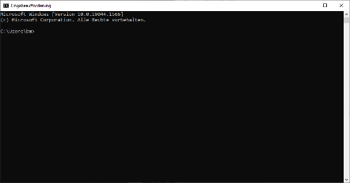In Windows Search:

Type **CMD** - the Command Entry should be the first found, click it and an old style DOS window opens

Know the location where the App is.

Type:

**<Drive letter>:** // e.g. D:

**cd <directory of the app>** // e.g. cd \myApps\HudBar

**dir** // list the contents – you should see the **FS20\_HudBar.exe** among others

**FS20\_HudBar.exe > DEBUG.txt** // this will Run the App and send some debug info to the file

Now try to reproduce the problem

Exit the HudBar and include the DEBUG.txt file in the failure report

Issues can be reported directly via GitHub (or a Message in Flightsim.to)

<https://github.com/bm98/FS20_HudBar/issues>

<https://flightsim.to/file/16604/msfs-hudbar>